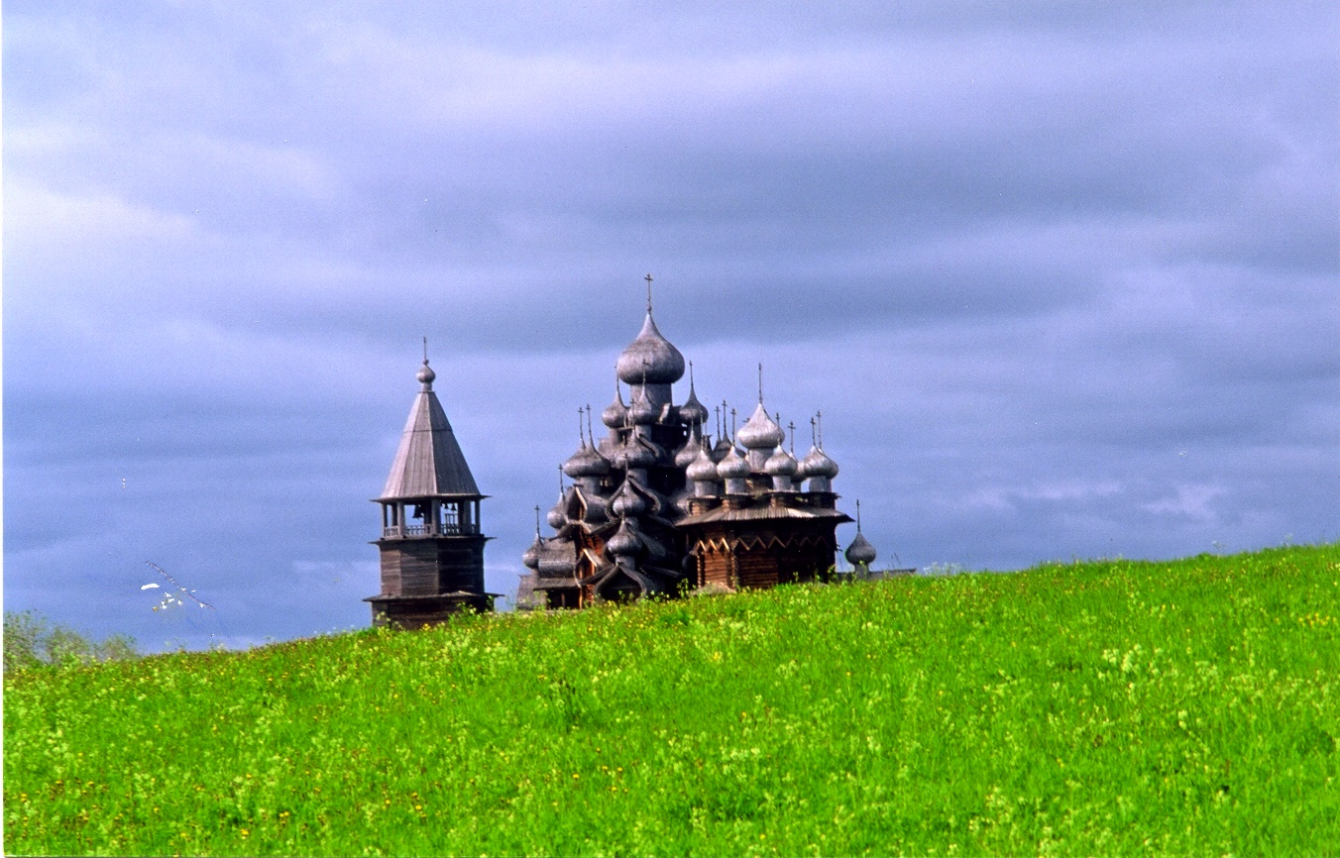
Fr. Andrew Applegate 250-420-1582
www.saintaidan.ca FOR COURSE DETAILS
ALL ARE
WECOME
Wednesday Evenings: 7:30 - 9:00 Oct. 4 - Nov. 29
Orthodoxy 101
to Follow
Refreshments
Discussion &
‘Journey to Fullness’
8 Week Video Series

Downstairs Hall
201 – 7th. Ave. S.

St. Aidan Orthodox Church

(An Introduction to Ancient Christianity) Christianity

Dear St. Aidan friends and family;
We will be holding a series of Wednesday night “Orthodoxy 101” teaching and discussion sessions learning about the Orthodox faith, downstairs at the Church starting on Wednesday Oct. 4. These sessions would be a great opportunity to introduce any friends that you may have that may have an interest in learning about the Orthodox Church and spirituality to the Orthodox Faith. Please consider inviting someone and attending with them. Theses sesions would also be a great chance for couples to come together or for any of our parishioners to learn more about their Orthodox faith. It is always ideal at such teaching sessions to have a good mix of inquirers/catechumens and faithful Orthodox parishioners.
We will be using Fr. Barnabas Powell’s 16 session Video series “Journey to Fullness” as a teaching and discussion starter each Wednesday. They are 20 minutes long so the format will be to show a 20-minute video, have 20 minutes of discussion, show another 20-minute video and finish off with a 1/2 hour of discussion and tea and cookies. This way we will be able to complete the series in an 8-week period. Please call or e-mail me to sign up so I can make sure I have enough work books for everyone who comes. If you are interested in supplying some cookies for a session or two please let me know as well!
Check out a short 5 min. Video on the course here: https://youtu.be/a6J390hbMqI
Love in Christ……..fr andrew…………. 250-420-1582

Journey to Fullness (Fr. Barnabas Powell) 16 lesson Outline (20 min. each)
Wed. Oct. 4: Lesson 1: “Is this trip really Necessary? Lesson 2: What is the Orthodox Church?
Wed. Oct. 11: Lesson 3: When did Orthodoxy Begin? Lesson 4: Characteristics of Orthodox Christianity.
Wed. Oct. 18: Lesson 5: Mindset Matters, Lesson 6: A Healing Purpose.
Wed. Oct. 25: Lesson 7: Truth and Tradition, Lesson 8: How do I understand the Bible?
Wed. Nov. 1: Lesson 9: When we say God Part 1; Lesson 10: When we say God Part 2
Wed. Nov. 8: Lesson 11: God with us, Lesson 12: Our Ultimate Purpose
Wed. Nov. 15: Lesson 13: Salvation as Participation, Lesson 14: Orthodox Worship
Wed. Nov. 22: Lesson 15: A Beautiful Rhythm, Lesson 16: The Journey Continues

